3GPP TSG-RAN WG1 Meeting #125 R1-2604518
Dalian, China, May 18th ~ 22th, 2026
Agenda Item: 10.8.1
Source: Southeast University
Title: Discussions on 6G ISAC Scenarios and Evaluations
Document for: Discussion

1 Introduction
ISAC has been recognized as an important study item for NR and 6GR. In RP-253876 [1], the objective of FS_6G_Radio explicitly included sensing-related studies based on use cases and requirements, covering e.g. sensing performance evaluation and aspects of integration with communication services.
(9) Sensing – Studies to be based on use cases and associated requirements, as defined in [TR38.914]
- PHY functions and procedures for sensing technology (e.g., waveform. reference signals, measurement feedback, etc…) [RAN1, RAN4]
- Evaluate sensing performance and if necessary, extend channel modelling, for the selected use cases [RAN1]
- Aspects of integration with communication services [RAN1]
- higher layer procedures and protocol aspects [RAN2]
- RAN4 aspects of sensing including RF, coexistence, and testability in coordination with other WGs [RAN4]
Note: RAN1 identify detailed requirements, if triggered by TSG RAN
TR 38.914 further specified the use cases and the associated requirements of 6GR ISAC. To be detailed, it further specified the use case of detecting passive objects, including UAVs as a sensing target [2]:
5.4.4 Sensing

The 6GR and 6G RAN architecture shall at least support use cases of
- detection and/or tracking of passive objects, at least including UAVs, human, vehicles and AGVs,
- communication assistance.
In the last meeting RAN1#124-bis, most of companies have reached a consensus on viewing UAVs as the sensing targets for object detection/tracking [3]:
[On1][H] Proposal 4.1-1

For Rel-20 6G sensing performance evaluation, at least evaluate object detection and/or tracking for the following sensing targets/objects: UAV, human, vehicle, AGV.
In this contribution, we primarily discuss a new sub-use case on UAV detection without introducing additional sensing signal, present our perspective and provide our evaluation results on this sub-use case.

2 Discussion
In previous discussion, companies have achieved progress on for gNB-based mono-static sensing for UAV sensing target use cases, where FR1 is prioritized, and existing DL NR waveform/reference signals are used as the starting point for evaluation [4].
This study item aims to study the following aspects for Integrated Sensing and Communication (ISAC):

Evaluate the performance of gNB-based mono-static sensing (i.e., single TRP with co-located sensing transmitter and receiver) for UAV use case [RAN1]
- Identify and study metrics, measurements, and relevant measurement quantization for UAV use case
- As baseline, existing DL NR waveform and DL NR reference signals are to be used for evaluations.
  - For other waveform and reference signals, companies are to share relevant information
  - No UE impacts
- Deployment scenario and assumptions for channel model calibration for UAV sensing targets in the Rel-19 ISAC channel model SI [FS_Sensing_NR] are used as starting point for evaluation assumptions.
  - FR1 frequency range is prioritized.

Study the procedures, signaling between RAN and CN to support ISAC [RAN3]

Study network architecture for gNB-based mono-static sensing for UAV sensing target use cases [RAN3]
- Applicability to gNB bistatic sensing may be considered as part of this network architecture without additional architecture impacts.
- No inter-gNB coordination will be studied.
- Coordination with SA2 as necessary.

In RAN1#124bis, companies expressed diverse views on the sensing modes for 6G ISAC evaluations [3]. All six sensing modes received support from multiple companies, while TRP-monostatic and TRP-UE/UE-TRP bistatic modes attracted relatively broader interest. In addition, multi-static sensing and cooperative sensing were also mentioned:
Motivated by this, in this contribution, we focus on a bistatic sensing case for UAV detection task, which reuses existing reference signal for sensing.

2.1 Motivation
While achieved favorable results, current monostatic sensing framework still has limitations for practical low-altitude UAV detection. When only BS monostatic sensing is used, the sensing geometry is constrained by BS deployment and antenna configuration. For example, BS downtilt and sparse BS deployment may reduce sensing coverage for aerial targets. If distributed sensing is further extended by using mobile UEs, UE mobility may introduce additional uncertainty in sensing geometry and node availability. Moreover, previous discussions have already highlighted that different sensing measurement levels/options are associated with different payload overhead and higher-layer aspects. Therefore, both sensing performance and sensing cost should be considered.

2.2 Discussion on Cooperative UAV Sensing With FWA CPEs
Fixed wireless access (FWA) customer premises equipment (CPEs) [5][6] can be attractive sensing nodes for UAV detection. Compared with BSs, which are sparsely deployed, and mobile UEs, which lack stability due to mobility, CPEs are statically deployed at fine granularity, and their static and dense nature makes them appealing candidates for cooperative sensing. Therefore, BS-CPE cooperation can provide more stable sensing geometry and richer spatial observations for ISAC UAV detection.

In addition, a BS-CPE cooperative framework can also be attractive from the overhead perspective. Existing uplink channel state information (CSI) already available in the communication system can be reused for UAV sensing, thereby exploiting the existing infrastructure without requiring dedicated additional sensing signal transmission. Moreover, by first performing local processing and then forwarding only lightweight local decisions for cooperative fusion, the sensing-data transmission overhead can be significantly reduced. Since CSI encodes fine-grained propagation characteristics, such as multipath signatures, it can provide informative observations for environment inference and cooperative sensing.

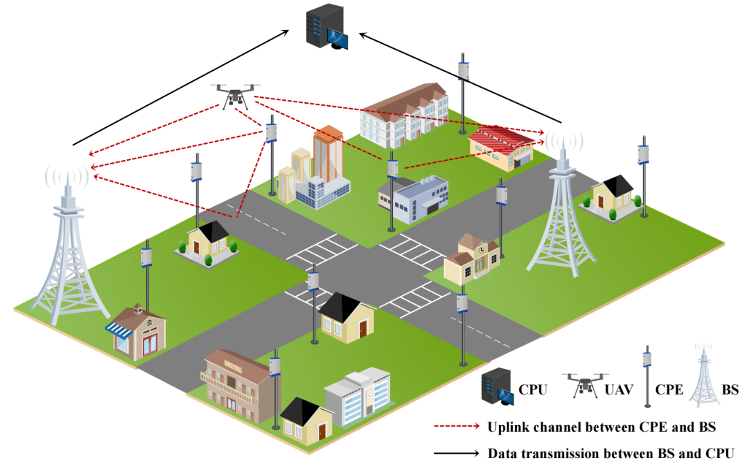
Fig. 2.2-1. Illustration of a BS-CPE cooperative UAV sensing scenario. Widely deployed FWA CPEs can serve as wireless cameras and provide complementary sensing observations.

Based on the above observations, it is worthwhile to further discuss whether BS-CPE cooperative sensing can be considered as a relevant scenario extension for UAV detection. In this part, we provide our views on cooperative sensing with FWA CPEs. Specifically, uplink transmission in a MIMO-OFDM system is reused for sensing. The scenario consists of a central server, multiple BSs, multiple CPEs. Each CPE can communicate with each BS, thereby forming multiple BS-CPE pairs, and each pair provides one sensing link. The UAV is treated as a passive scatterer, whose presence perturbs the propagation channels of some BS-CPE pairs. Therefore, the uplink CFR collected over all BS-CPE pairs can be jointly exploited for UAV detection using the existing communication infrastructure.

The proposed method adopts a two-stage cooperative detection framework [7]:

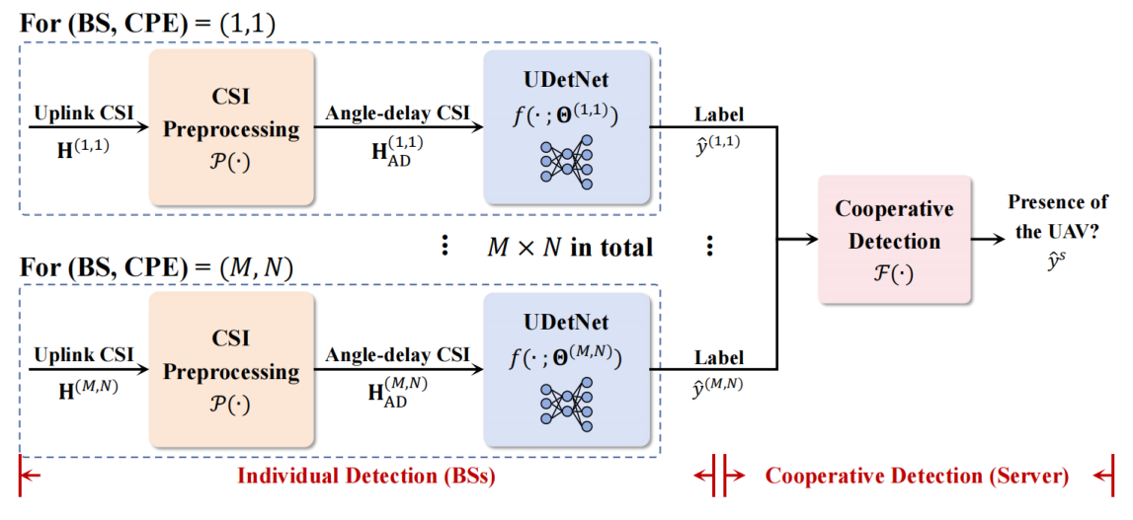
Fig. 2.2-2. The two-stage cooperative UAV detection framework.

- In the first stage, each BS-CPE pair performs individual detection using only its local CSI observation. To make the CSI representation more suitable for sensing, the CFR is transformed from the space-frequency domain into the angle-delay domain, and then fed into an AI-based detector to determine whether the CSI of that specific BS-CPE pair is affected by the UAV. In other words, each pair independently outputs a local binary sensing result indicating whether it contains UAV-related channel perturbation.

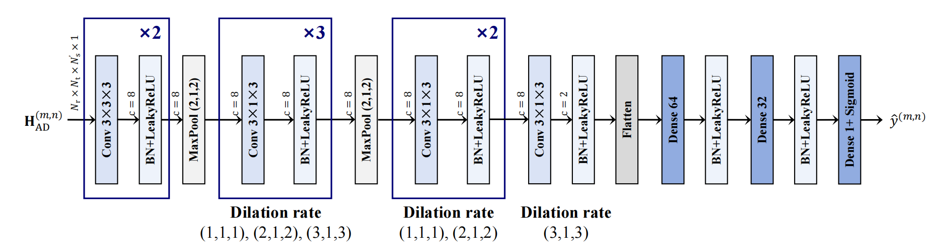
Fig. 2.2-3. The neural network architecture for individual detection.

- In the second stage, the local detection results from all BS-CPE pairs are forwarded for cooperative fusion. Instead of sending raw CSI to the central server, only lightweight local binary decisions are exchanged. The final UAV presence decision is then made by fusing these distributed local results, e.g. by comparing the number of positive BS-CPE detections against a decision threshold $σ_{d}$. In this way, the framework exploits the complementary sensing coverage of multiple BS-CPE links while keeping the information exchange overhead low.

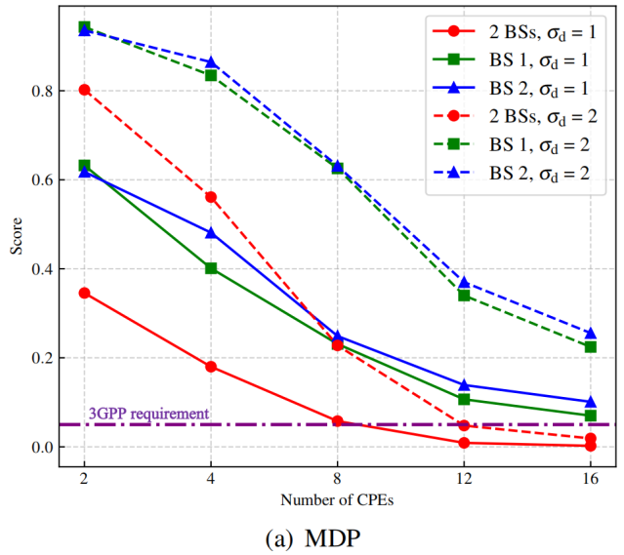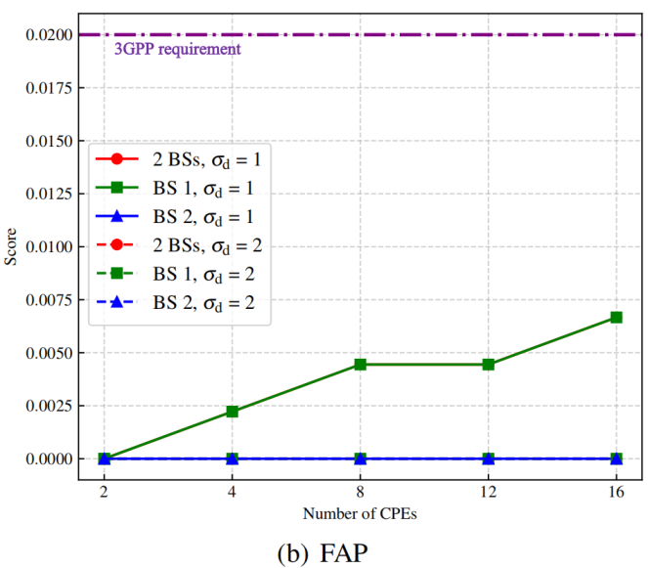
Fig. 2.2-4. Cooperative detection performance with different threshold $σ_{d}$ and numbers of BSs/CPEs.

This two-stage design is relevant for ISAC discussion for two reasons. First, by jointly using multiple BS-CPE pairs, it improves sensing robustness through richer observation geometry and spatial diversity. Second, by reusing existing uplink CSI and avoiding raw-CSI forwarding, it significantly reduces sensing transmission overhead, which is consistent with the need to jointly consider sensing performance and sensing information delivery cost.

The proposed BS-CPE cooperative sensing framework can be beneficial for improving detection performance. As shown below, the cooperative scheme significantly reduces the missed detection probability (MDP) to 0.22%, which is below the 3GPP 5% requirement [2]. This suggests that CSI-based BS-CPE cooperative sensing is worthwhile to discuss as a possible direction for improving ISAC sensing reliability with manageable overhead.

3 Conclusion
Based on previous discussion, we made the following proposals:

Proposal 1: Study BS-CPE cooperative sensing for ISAC as a possible scenario extension to the current gNB-monostatic sensing baseline, where FWA CPEs can be considered as fixed wireless cameras to provide complementary sensing observations together with BSs, thereby enlarging sensing coverage and potentially improving sensing accuracy by reusing existing network infrastructure.

Proposal 2: Study CSI-based passive sensing for ISAC, which direct reuse of existing communication signals and channel measurements for sensing support, without introducing dedicated additional sensing signal transmission.

References
- RP-253876, “Revised SID: Study on 6G Radio”, NTT DOCOMO, CMCC, AT&T, Vodafone, RAN#110, Baltimore, US, December 8-11, 2025.
- 3GPP, “ TR 38.914 V0.4.0: Study on 6G Scenarios and Requirements (Release 20)”, 2026.
- R1-2602521, “FL summary #4 on ISAC evaluations”, CATT, RAN1#124-bis, St Julian's, Malta, April 13-17, 2026.
- RP-253246, “Revised SID: Study on Integrated Sensing And Communication (ISAC) for NR”, Xiaomi, China Telecom, RAN#110, Baltimore, US, December 8-11, 2025.
- Ericsson, “Fixed wireless access,” 2024. [Online]. Available: https://www.ericsson.com/en/fixed-wireless-access/
- 3GPP, “TR 22.837: Feasibility study on integrated sensing and communication,” 2024.
- J. Zhang, J. Guo, X. Li, C.-K. Wen and Shi Jin, “Deep Learning-Based Cooperative UAV Detection With CPE-Assisted Sensing”, accepted by IEEE International Conference on Communications (ICC) Workshop, Glasgow, Scotland, UK, 2026.

